https://learn.microsoft.com/en-us/cpp/build/x64-calling-convention?view=msvc-170
The Microsoft x64 calling convention is the standard ABI (Application Binary Interface) used on 64-bit Windows.
The convention defines how parameters must be passed to functions, how the stack needs to be aligned, how functions return values and which registers must be preserved.
For our own functions we can deviate from the convention. But best practice is to stick to the convention. When making calls to something like the Windows API or MSVCRT (Microsoft Visual C++ Runtime Library) it's essential to stick to the calling convention otherwise the software will malfunction.
Stack alignment
Before calling a Windows API function the stack needs to be 16 byte aligned. Additionally its also required to reserve 32 bytes of shadow space (shadow store). If a function has more than four parameters the additional parameters are passed on the stack. Each stack argument occupies 8 bytes.
Why the stack alignment is needed
There are instructions that expect 16 byte alignment. Especially the SIMD instructions. Stack alignment also helps the CPU to run the code safely and efficiently.
Parameter passing via registers
Integer valued arguments/parameters are passed in RCX, RDX, R8, R9 (in this order). The remaining parameters are passed on the stack.
What is considered as integer arguments: Everything that is not a floating point value. (Float or double)
Some Windows API functions expect float or double parameters. For example: GDI+, Direct2D/Direct3D, DirectXMath etc.
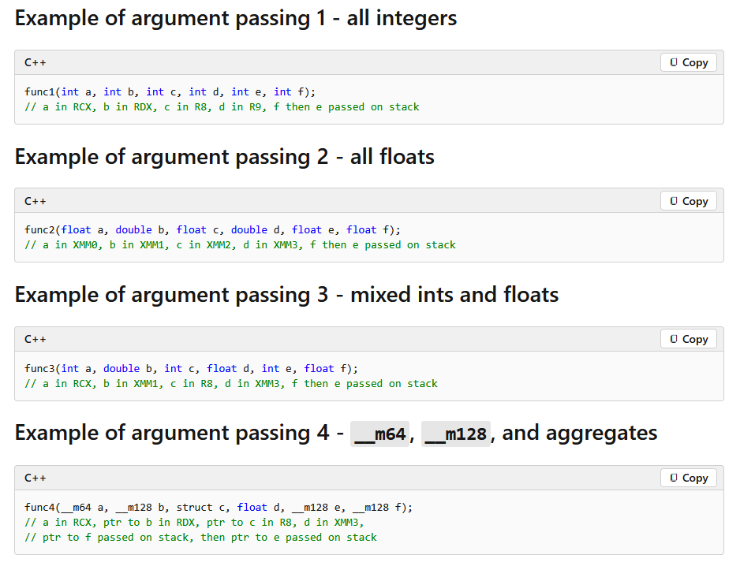

Variadic function
From the MSDN
If parameters are passed via varargs (for example, ellipsis arguments), then the normal register parameter passing convention applies.
For vararg or unprototyped functions, any *floating point values must be duplicated in the corresponding general-purpose register.
What the MSDN is telling us:
For a variadic function there is no fixed number of arguments/parameters. varargs means variable arguments. varargs still follow the normal positional register.
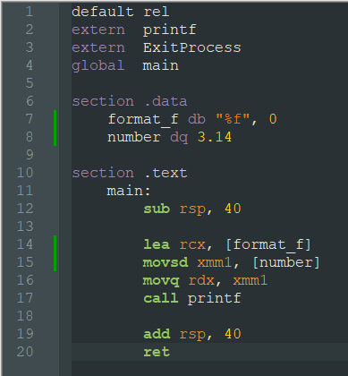

Normally we would expect that we need only need to use RCX and XMM1 but in this case we need also to use the RDX register. *We have duplicated the floating point value in the corresponding general-purpose register. Because printf is a variadic function.
Aggregates in C group multiple variables into a single type:
Example:
struct CAR {
int id; // 4 byte
char brand[12]; // 12 byte
int speed; // 4 byte
}
A struct (structure) in NASM
struc CAR
.id: resd 1 ; 4 byte (DWORD)
.name: resb 12 ; 12 Bytes
.speed: resd 1 ; 4 byte (DWORD)
endstruc

func (float a, float b, int c, float d, float e)
a = XMM0
b = XMM2
c = R8
d = R9
e = Stack
Parameter | Integer valued | Floating point
1st | RCX | XMM0
2nd | RDX | XMM1
3rd | R8 | XMM2
4th | R9 | XMM3
5th | Stack | Stack

Exercises
Try to determine which parameter goes into which register.
Task 1:
func_1 (float a, int b, float c, int d, float e, int f)
Task 2:
func_2 (int a, int b, int c, float d, float e, int f)
Register preservation
After calling a windows API function there is no guarantee that the following registers will keep their previous value:
RAX, RCX, RDX, R8, R9, R10, R11, XMM0-XMM5
Therefore its import to save the register values if they are still needed after the execution of a Windows API function. These registers are called the volatile registers.
Non-volatile register:
RBX, RBP, RDI, RSI, R12, R13, R14, R15, RSP, XMM6-XMM15
Its guaranteed that these registers preserver their previous values after the execution of a Windows API function.
Return value
From the msdn:
- A scalar return value that can fit into 64 bits, including the __m64 type, is returned through RAX.
- Nonscalar types including floats, doubles, and vector types such as __m128, __m128i, __m128d are returned in XMM0.

Solutions for the Exercises
Task:1
func_1 (float a, int b, float c, int d, float e, int f)
a = XMM0
b = RDX
c = XMM2
d = r9
e = Stack
f = Stack
Task 2:
func_2 (int a, int b, int c, float d, float e, int f)
a = RCX
b = RDX
c = R8
d = XMM3
e = Stack
f = Stack

